**Q. Steps to Deploy Applications with Intune**

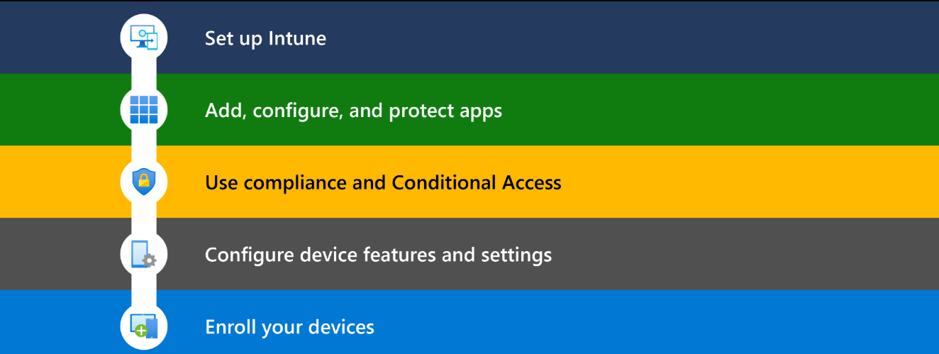

Step 1: Access the Microsoft Intune Admin Center

Use this URL:

Sign in using your administrator credentials.

Step 2: Add a New Application

In the left-hand menu, select **Apps** > **All apps**.

Click on **+ Add** to start the app deployment process

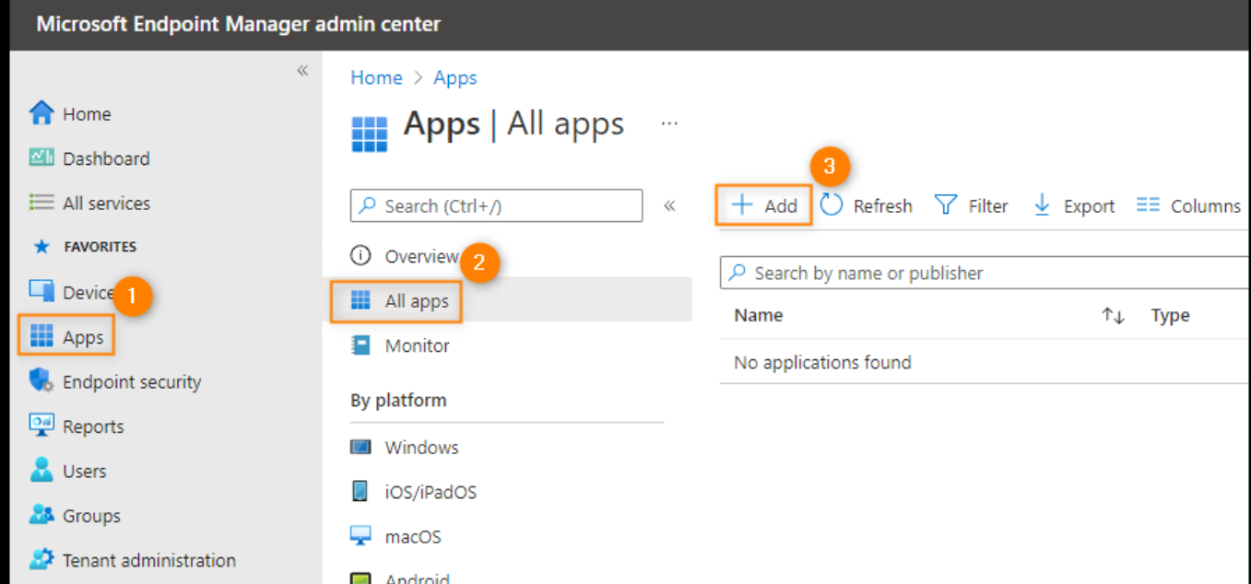

Step 3: Choose the Application Type

In the Select app type dropdown, choose the appropriate application type. For example:

Windows app (Win32) for .exe or .msi installers.

Microsoft 365 Apps for Office installations.

Click Select to proceed.

Step 4: Configure App Information

Provide necessary details:

Name: The application's name.

Description: A brief description of the app.

Publisher: The application's publisher.

Upload the app package file if required

Step 5: Define Program Installation Commands

Specify the installation and uninstallation commands. For example:

Install command: setup.exe /quiet

Uninstall command: setup.exe /uninstall

Configure the return codes and restart behavior as needed.

Step 6: Set Requirements

Define the operating system architecture (e.g., 64-bit) and minimum OS version required for the app.

Step 7: Configure Detection Rules

Set up rules to detect if the app is already installed. This helps Intune determine whether to install or skip the app.

For example, check for the existence of a specific file or registry key.

Step 8: Assign the App to Devices or Users

Choose the groups that should receive the app:

Required: Automatically install the app.

Available for enrolled devices: Users can install the app from the Company Portal.

Uninstall: Remove the app from selected devices.

Step 9: Review and Create

Review all the configurations you've made.

Click Create to deploy the application